DEPARTMENT OF MECHATRONICS ENGINEERING



|  |  |  |
| --- | --- | --- |
| Group Members: | Roll No: | Section: |
| Muhammad Muzammil | 201180 | BEMTS-5-B |
| Muhammad Faiq Nasir | 201075 | BEMTS-5-B |
| Muhammad Waleed Tariq | 201111 | BEMTS-5-B |

**MT-317 Theory of Machines**

**Submitted to:**

**Dr Shakeel-ur-Rehman**

**Engr Hassan Nawaz**

ABSTRACT

Mechanisms are means of power transmission as well as motion transformers. A four-bar mechanism consists mainly of four planar links connected with four revolute joints. The input is usually given as rotary motion of a link and output can be obtained from the motion of another link or a coupler point. Straight line motion from four bar linkages has been used in several ways as in a dwell mechanism. This paper studies the straight-line motion obtained from planar four bar mechanisms and optimizes the design to produce the maximized straight-line portion of the coupler point curve. The equations of motion for four different four-bar mechanisms will be derived and dimensional requirements for these mechanisms will be obtained in order to produce the straight-line motion. A procedure will be studied and CAD model made on solid works will be presented. Following the numerical results study, a synthesis procedure will be given to help a designer in selecting the optimized straight-line motion based on design criteria.

**Table of Contents**

• Statement: 5

• Objective: 6

• Introduction: 6

• Four Bar Mechanism: 7

• Applications: 8

Pump Jack (Rotary to Reciprocal): 8

Hammering Machine 9

• Synthesis (Four Bar Quick Return): 10

• Calculations: 10

Position Analysis: 10

Velocity Analysis: 10

Acceleration Analysis: 12

• MATLAB 13

Link Lengths: 13

Input Crank Angle: 13

Lengths and Angles: 13

Position of Joints: 14

Plots and Grids 15

Simulation 15

• Solid works: 16

Parts 16

Assembly 19

• Conclusion: 19

PROJECT TITLE:

Four Bar Linkage: Quick Return Mechanism

# Statement:

The objective of this project is to design a Mechanism of four or more Links. Some examples of such mechanism are given below:

The students are expected to carry out following steps:

* Select a multiple bar linkage mechanism.
* Perform its synthesis.
* Perform the position analysis.
* Perform the velocity analysis.
* Perform the acceleration analysis.

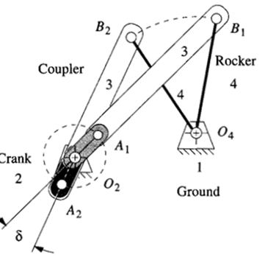

Figure 1: Quick Return Mechanism

# Objective:

The objective of this project requires abstract thinking in analysis to formulate a suitable software model:

* To design a four-bar linkage.
* Do all calculation on hard form.
* Prove Grashoff condition. Show proper animation

# Introduction:

One of the main objects of designing a mechanism is to develop a system that transforms motion in a specific way to provide mechanical advantage. A typical problem in mechanism design is coordinating the input and output motions. A mechanism designed to produce a specified output as a function of input is called a function generator. Such a function generator which can produce a straight-line output has found a wide variety of applications. A system that transmits forces in a predetermined manner to accomplish specific work may be considered a machine. A mechanism is the heart of a machine. It is a device that transforms one motion, for example the rotation of a driving shaft, into another, such as the rotation of the output shaft or the oscillation of a rocker arm. A mechanism consists of a series of connected moving parts which provide the specific motions and forces to do the work for which the machine is designed. A machine is usually driven by a motor which supplies constant speed and power. It is the mechanism which transforms this applied motion into the form demanded to perform the required task. The study of mechanisms is very important. With the tremendous advantages made in the design of instruments, automatic controls, and automated equipment, the study of mechanisms takes on new significance.

# Four Bar Mechanism:

A four-bar linkage is a versatile mechanism that is widely used in machines to transmit motion or to provide mechanical advantage It is also the most fundamental linkage mechanism, and many more complex mechanisms contain the four-bar linkage as elements. Therefore, a basic understanding of its characteristics is essential. A four-bar mechanism consists of four rigid members: **the frame or fixed member, to which pivoted the crank and follower, whose intermediary is aptly termed coupler.** These members are connected by four revolute pairs. A Four-Bar Linkage with Coupler Point on AB is called the coupler point, and its path when the crank is rotated is known as a coupler point curve or coupler curve and the number of such curves are infinite. By proper choice of link proportions and coupler point locations useful curves may be found. A curve's usefulness depends on the shape of a segment, for example, an approximate straight line or a circular arc, or on a peculiar shape of either the whole curve or parts of it. The coupler point because of its motion characteristic, is now the output of the linkage.

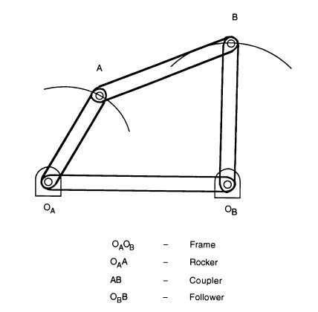

Figure 2: Four Bar Mechanism

# Applications:

## Pump Jack (Rotary to Reciprocal):

In areas where underground oil is not under enough pressure to drive it all the way to the surface, it is necessary for oil wells to actively pump up the oil. One standard method for achieving this is to use a reciprocating piston that pumps the oil up the shaft. As most motors (electrical or internal combustion) provide a rotating drive shaft, some way is needed to convert the rotary engine motion into reciprocating pump motion. A pumpjack is a drive mechanism to achieve this, consisting of a four-bar linkage as shown below. The heavy rotating counterweight is arranged so that it is falling while the pump is performing the upstroke, and thus lifting the oil against gravity. This allows a smaller engine to be used.

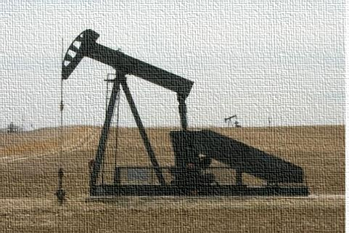

Figure 3: Pump Jack

## Hammering Machine

Hammering is the most widely used industrial as well as construction activity. Hammering or screws, metal sheets, parts etc requires a lot of time and effort. So here we propose an automated hammering system that allows for fully automatic hammering process. This allows for accurate, fast and automated hammering wherever and whenever needed using a 12V battery. The person just needs to insert workpiece and start the hammering machine. This machine can be used for automatic hammering work as and when needed. We here use a dc motor in order to move the hammer. The DC motor consists of a pulley attached to it which is connected to a larger pulley for efficient power transfer and to increase torque. This large pulley is connected to a shaft that has a connecting rod attached to it. This rod is used to achieve lateral motion from the spinning shaft.

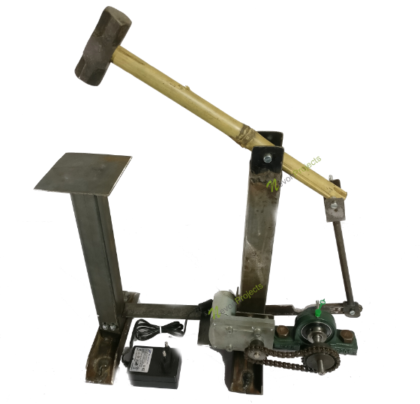

Figure 4: Automated Hammering Machine

# Synthesis (Four Bar Quick Return):

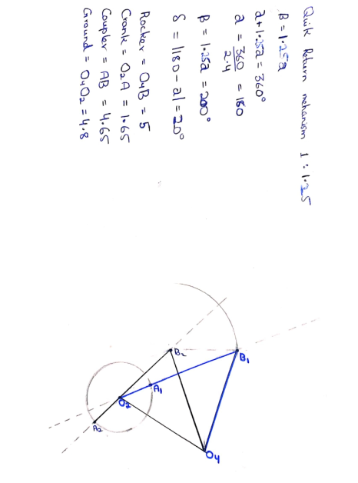

Figure 5: Quick Return Mechanism Synthesis

# Calculations:

## Position Analysis:

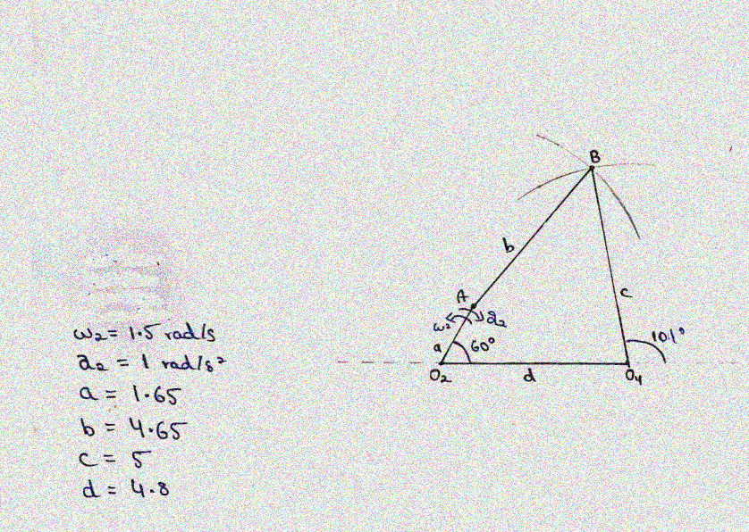

Figure 6: Graphical Position Analysis

## Velocity Analysis:

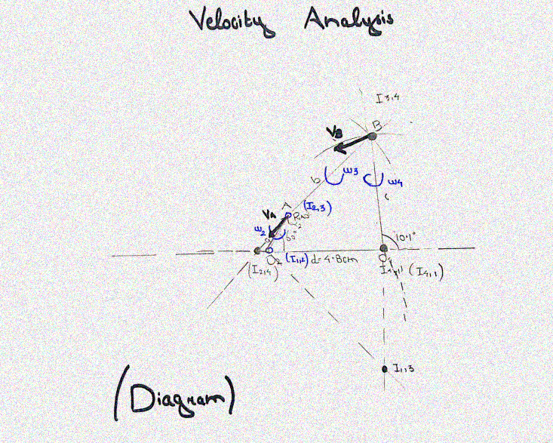

|  |  |
| --- | --- |
|  |  |

Figure 7: Graphical Velocity Analysis

## Acceleration Analysis:

|  |  |
| --- | --- |
|  |  |

**Figure 8: Acceleration Analysis**

# MATLAB

## Link Lengths:

The lengths of the links calculated before are specified in the code. The output link is a ternary link, so its end points are specified using two variables.

clc

clear all

% Link Lengths (in cm)

Link1 = 4.8; %Ground Link

Link2 = 1.65; %Crank

Link3 = 4.65; %Coupler

Link4_A = 5; %Rocker (O4 to C)

Link4_B = 3; %Rocker (O4 to D)

Link5 = 1.75; %Driller Coupler

Link6= 4; %Driller

## Input Crank Angle:

The angle of the input link (crank) is varied from 0° to 360° with an increment of 1°. This way the crank undergoes one complete rotation.

%crank angle variation

theta2 = 0:1:360;

for i = 1:length(theta2)

## Lengths and Angles:

To get the position of each joint, some lengths and angles are calculated for each value of the input angle. A for loop is used that starts from 1 and goes until the length of theta2 which is 360 in the current case.

%Distance between A and O4

A_O4(i) = sqrt(Link1^2 + Link2^2 - 2*Link1*Link2*cosd(theta2(i)));

%Angle between A_O4 and x-axis

beta(i) = acosd((Link1^2 + A_O4(i)^2 - Link2^2)/(2*Link1*A_O4(i)));

%Angle between Link3 and A_O4

psi(i) = acosd((Link3^2 + A_O4(i)^2 - Link4_A^2)/(2*Link3*A_O4(i)));

%Angle between Link4 and A_O4

lamda(i) = acosd((Link4_A^2 + A_O4(i)^2 - Link3^2)/(2*Link4_A*A_O4(i)));

%Angle between Link4 and negative x-axis

alpha(i) = 180 - beta(i) - lamda(i);

%Angle of Link3 with positive x-axis

theta3(i) = psi(i) - beta(i);

%Angle of Link4 with positive x-axis

theta4(i) = 180 - beta(i) - lamda(i);

%when crank is in the third and fourth quadrants

if(theta2(i) > 180)

%Angle of Link3 with positive x-axis

theta3(i) = psi(i) + beta(i);

%Angle of Link4 with positive x-axis

theta4(i) = 180 - lamda(i) + beta(i);

%Angle between Link4 and negative x-axis

alpha(i) = 180 - lamda(i) + beta(i);

end

## Position of Joints:

The joint O2 is on origin hence its coordinates are (0,0). For the x component of Joint A, the x component of O2 is added in the x component of the link2. Similarly, for the y component of Joint A, the y component of O2 is added in the y component of the link2. Next for the x component of Joint B, the x components of O2 and joint A and the x component of link3 are added. Similarly, for the y component of Joint B, the y components of O2 and joint A and the y component of link3 are added For second ground position O4, the y component is 0 while the x component is the same as the length of the Link1(Ground Link). For the x component of point D we added cos(theta4) of link 4B to x of O4 and sin(theta4) of link 4B for y component of D. The rest point E and F are extensions of rocker that just represents the output created.

% Positions of Joints

%Position of O2

O2_x(i) = 0;

O2_y(i) = 0;

%Position of A

A_x(i) = O2_x(i) + Link2*cosd(theta2(i));

A_y(i) = O2_y(i) + Link2*sind(theta2(i));

%Position of B

B_x(i) = O2_x(i) + A_x(i) + Link3*cosd(theta3(i));

B_y(i) = O2_y(i) + A_y(i) + Link3*sind(theta3(i));

%Position of O4

O4_x(i) = Link1;

O4_y(i) = 0;

%Position of D

D_x(i) = O4_x(i) + Link4_B*cosd(theta4(i)-180);

D_y(i) = O4_y(i) + Link4_B*sind(theta4(i)-180);

%Position of E

E_x(i) = D_x(i) - Link5;

E_y(i) = -3;

%Postion of F;

F_x(i) = E_x(i) - Link6;

F_y(i) = -3;

## Plots and Grids

%Plot of All the Joints

plot([O2_x(i) A_x(i)], [O2_y(i) A_y(i)],[A_x(i) B_x(i)], [A_y(i) B_y(i)],[B_x(i) O4_x(i)], [B_y(i) O4_y(i)], [O4_x(i) D_x(i)], [O4_y(i) D_y(i)], [D_x(i) E_x(i)], [D_y(i) E_y(i)], [E_x(i) F_x(i)], [E_y(i) F_y(i)], 'LineWidth', 4);

title('Pump Jack 201111,201180,201075 ');

%Turn on grid

grid on;

%Axis limits

axis([-2 10 -5 6]);

%rotate(, 90, [0,0]);

%modifies the plot

drawnow;

end

## Simulation

|  |  |
| --- | --- |
|  |  |

Figure 9: Matlab Simulation

# Solid works:

## Parts

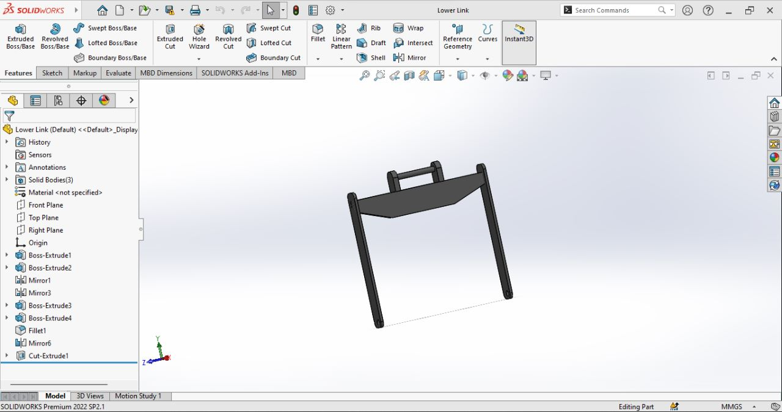

**Figure 10: Coupler**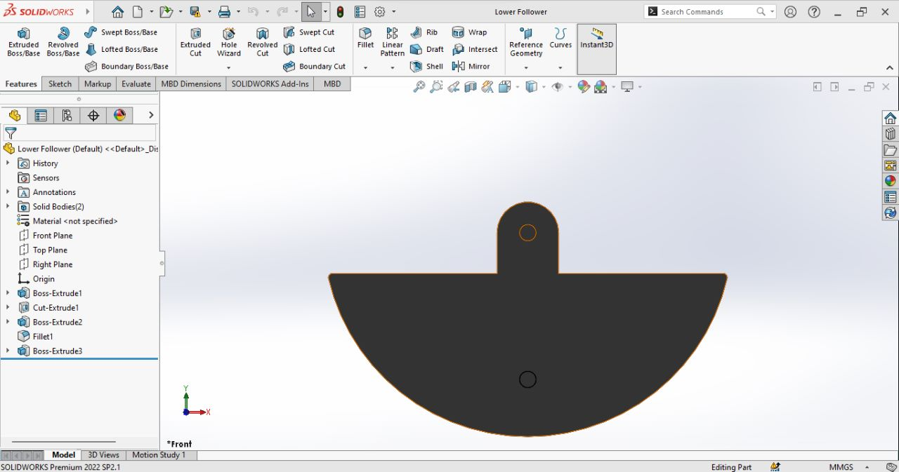

**Figure 11: Crank**

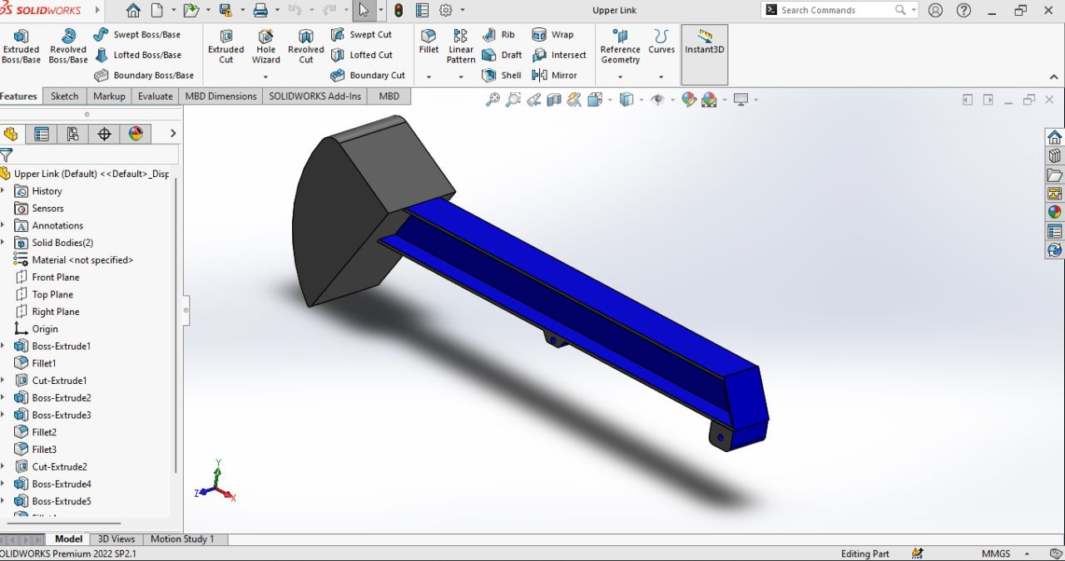

**Figure 12: Rocker**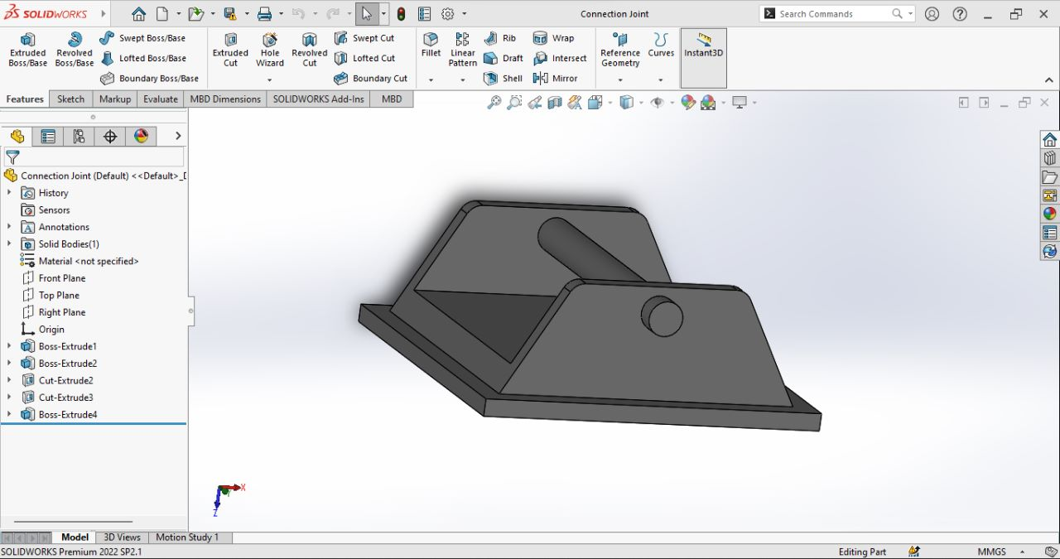

**Figure 13: Ground (Crank)**

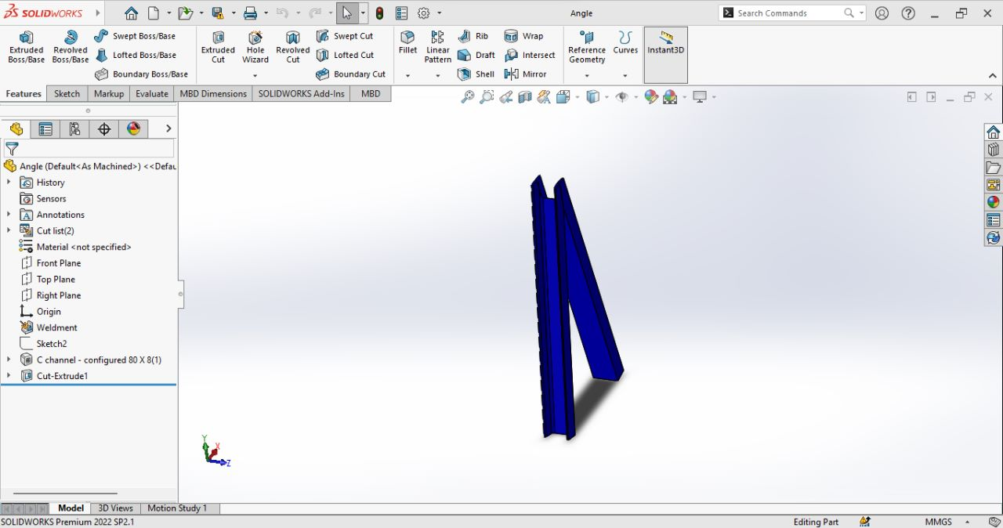

**Figure 14: Ground (Rocker)**

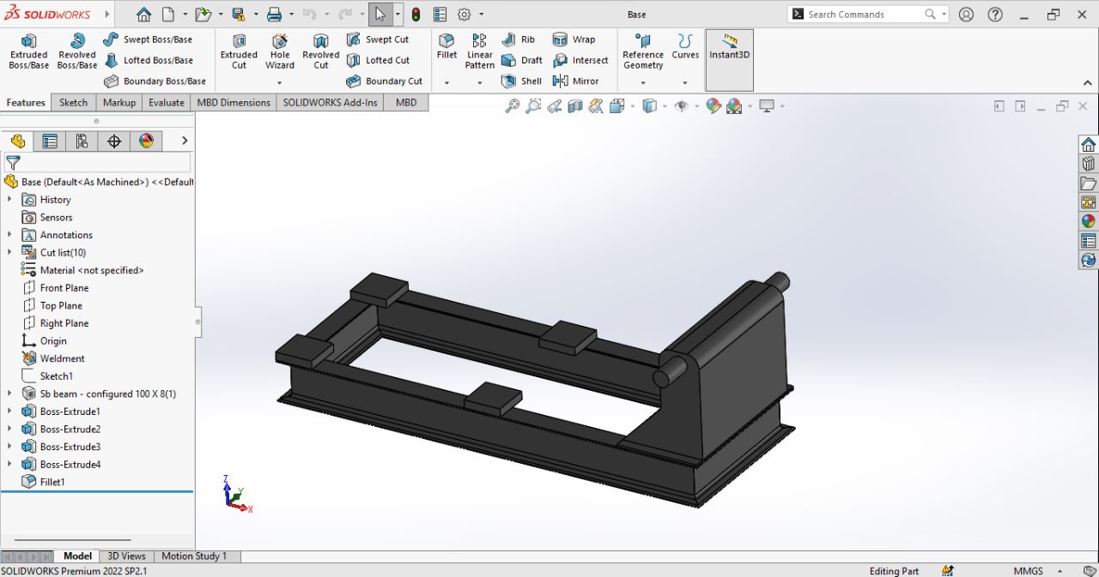

**Figure 15:Ground (Base)**

## Assembly

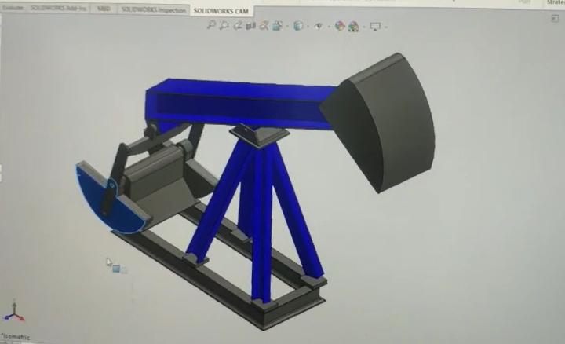

# Conclusion:

The mechanism of Crank-Rocker is applicable to the design of various machines likes sewing machine, mixer, shaper, and other equipment etc. as we see the example of a pumpjack. A pumpjack is a drive mechanism to achieve this, consisting of a four-bar linkage. A beam type pump jack converts the rotary motion of the motor to the vertical reciprocating motion. The heavy rotating counterweight is arranged so that it is falling while the pump is performing the up-stroke, and thus lifting the oil against gravity. This allows a smaller engine to be used.